TABLE OF CONTENTS
EXECUTIVE SUMMARY 1
INTRODUCTION 2
CONTENTS OF PROJECT 5
FINANCIAL ANALYSIS 6
1) COMPARISON OF BOOK VALUE AND MARKET VALUE OF SHARE 6
NUMBER OF SHARE OUTSTANDING 6
2) TRENDS IN CHANGE OF NET INCOME 7
PREVIOUS YEAR 7
3) FIRM TAXBARCKET AND AVERAGE TAX 8
4) DIVIDEND POLICY, RETENTION RATE, RETURN ON EQUITY, GROWTH RATE 9
DIVIDEND POLICY: 9
RETENTION RATE: 10
RETURN ON EQUITY : 11
TOTAL EQUITYS 11
GROWTH RATE : 12
5)CAPITAL STRUCTURE 13
WACC (WEIGHTED AVERAGE COST OF CAPITAL): 13
6) LAST YEAR YIELD 14
CAPITAL GAIN YIELD: 14
7) ACTUAL RATE OF RETURN, REQUIRED RATE OF RETURN, EXPECTED RATE OF RETURN, DIVIDEND DISCOUNT MODEL, INFINITE DIVIDEND PAYMENTS, CAPM 15
ACTUAL RATE OF RETURN: 15
DIVIDEND DISCOUNT MODEL : 17
INFINITE DIVIDEND PAYMENTS: 17
BETA CALCULATION 18
8)BREAK EVEN RUPEES 19
DEGREE OF OPERATING LEVERAGE: 20
9)COMPARISON OF REQUIRED RETURN WITH ACTUAL RATE OF RETURN 21
COMPARSION OF ACTUAL PRICE WITH CALCULATED PRICE 21
10)RATIOS 22
LIQUIDITY RATIO: 22
LEVERAGE RATIOS: 24
EFFICIENCY RATIOS: 26
PROFITABILITY RATIOS: 28
MARKET VALUE RATIO: 29
11)RECOMmANDATION 30
BIBLOGARPHY 33

EXECUTIVE SUMMARY

Servis Group is Pakistan’s largest footwear manufacturer and exporter. It also has interests in retailing – its sister company Service Sales Corporation is the country’s largest retailer and wholesaler of footwear. The Group has diversified interests in Textiles, Rubber products including tyres, defense industry products and in pharmaceutical retailing. This diversity in products portfolio gives Servis group a competitive advantage over its competitors. The performance of industry is doing well which is being reflected in the revenues of the evaluated company. In the years to come company will have to revise a strategy to cost leadership so it can be competitive as compare to low cost producers in china and china. Company should try to broader its exports volumes and try to look for new markets in Europe & America. The company can promote its premium brands in the high quality conscious markets of Europe & North America .
INTRODUCTION

SIL is a publicly traded company and has annual revenue of US $ 45 million. It is the largest manufacturer of tyres and tubes for two-wheelers, and has been the largest exporter of footwear from Pakistan for the last 10 years.
The company employs more than 4,000 people in its facilities located in Gujrat and Muridke. The company’s products are exported primarily to Germany, Italy, France and UK.
Business Review
Business achieved a healthy sales growth in almost all segments of the company’s business. The company has been successful in the efficient utilization of its resources, which has cushioned the impact of steep increase in raw material prices, financial charges and other operating costs. A significant improvement is profitability was thus achieved.
Footwear Division
The company has been successful in achieving better profit margins. Footwear sales have increased. Exports sales grew by 27% and local sales by 17%.It reflect the confidence respond by our customers in our consistent quality, customer service and dedication to meet delivery commitments. This is very hearting when we take into consideration severe completion posed by the cheap import of footwear from Far Eastern countries much of which is either subsidized by the country of export or in under – invoiced. Your Company has been drawing attention of Government towards this menace regularly

Tyre & Tube Division
Sales of tyre and tube division have increased by 19.5%over last year. The Company has placed strong emphasis on customer services especially to OEM’s. Distribution network has been made more efficient through reorganization of distributors territories. We have introduced tubes for cars and light trucks to supplements our readily existing product line.

We are making major investment in new plant for production of new quality of tyres and tube. We will keep doing so in the year 2006 and 2007.

The global phenomenon of increase in petro-based raw materials and natural rubber had a strong impact on our profitability. This impact was absorbed largely by improving our efficiency and some increase in price.
Directors / Management
Chaudhry Ahmed Saeed - Chairman
Mr. Shahid Hussain -Chief Executive
Mr. M. Ijaz Butt - Director
Mr. Muhammad Akram - Director
Chaudhry Ahmad Mukhtar - Director
Mr. Shahid H. Kardar - Director
Mr. Riaz Ahmed - Director
Mr. Asif Jameel - (Rep. of NIT)
Mr. Anis Wahab Zuberi - (Rep. of NIT)

CONTENTS OF PROJECT

- COMPARISON OF BOOK VALUE AND MARKET VALUE OF SHARE
- TRENDS IN CHANGE OF NET INCOME
- FIRM TAXBARCKET AND AVERAGE TAX
- DIVIDEND POLICY, RETENTION RATE, RETURN ON EQUITY, GROWTH RATE
- CAPITAL STRUCTURE
- LAST YEAR YIELD
- ACTUAL RATE OF RETURN, REQUIRED RATE OF RETURN, EXPECTED RATE OF RETURN, DIVIDEND DISCOUNT MODEL, INFINITE DIVIDEND PAYMENTS, CAPM
- BREAK EVEN RUPEES
- COMPARISON OF REQUIRED RETURN WITH ACTUAL RATE OF RETURN
- RATIOS
- RECOMANDATION

FINANCIAL ANALYSIS

1) COMPARISON OF BOOK VALUE AND MARKET VALUE OF SHARE

BOOK VALUE = TOTAL STOCKHOLDER EQUITY

NUMBER OF SHARE OUTSTANDING

YEAR | STOCKHOLDER EQUITY | NUMBER OF SHARE OUTSTANDING | BOOK VALUE | MARKET VALUE
2003 | 496,913,000 | 12,029,000 | 41.30958517 | 25
2004 | 523,815,000 | 12,029,000 | 43.5460138 | 29.3
2005 | 555,231,000 | 12,029,000 | 46.15770222 | 28.65

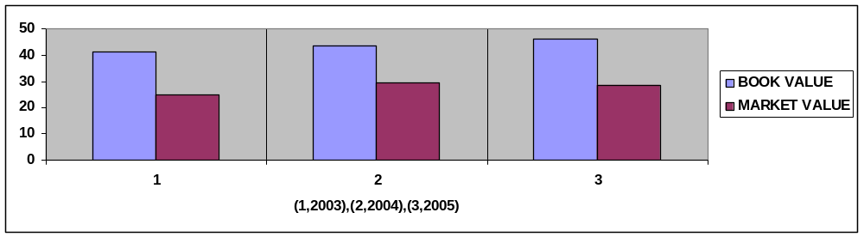

2) TRENDS IN CHANGE OF NET INCOME

CHANGE IN INCOME = CURRENT YEAR – PREVIOUS YEAR X 100

PREVIOUS YEAR

YEAR | NET INCOME(RS IN 000) | % CHANGE IN NETINCOME
2002 | 4723
2003 | 8832 | 86.99978827
2004 | 21783 | 146.6372283
2005 | 52259 | 139.9072671

3) FIRM TAXBARCKET AND AVERAGE TAX

AVG TAXATION OF THE COMPANY = TOTAL TAX X 100

EBT

YEAR | TOTAL CURRENT TAX (RS IN 000) | EBT (RS IN 000) | AVG TAX
2003 | 13192 | 22240 | 59.31654676
2004 | 14218 | 37126 | 38.29661154
2005 | 17077 | 74336 | 22.97271847

4) DIVIDEND POLICY, RETENTION RATE, RETURN ON EQUITY, GROWTH RATE

DIVIDEND POLICY:

PAYOUT RATIO = DIVIDEND X 100
EPS

YEAR | DIVIDEND | EPS | PAYOUT RATIO
2003 | 1 | 0.73 | 136.9863014
2004 | 1.5 | 1.81 | 82.87292818
2005 | 2 | 4.34 | 46.08294931

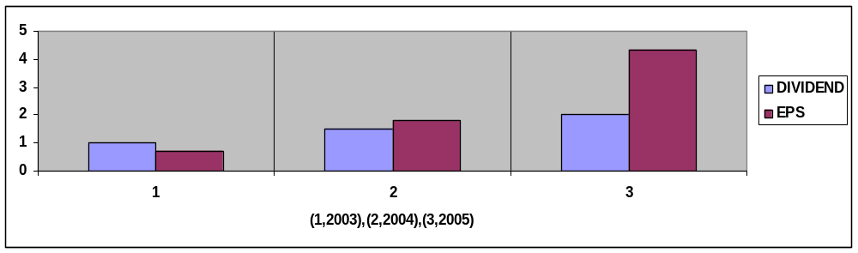

RETENTION RATE:

RETENTION RATE = (1 – PAYOUT RATIO)*100

YEAR | PAYOUT RATIO | RETENTION RATE
2003 | 1.369863014 | -36.9863014
2004 | 0.828729282 | 17.1270718
2005 | 0.460829493 | 53.9170507

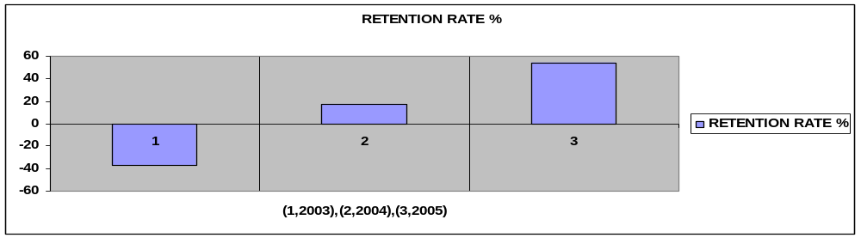

RETURN ON EQUITY :

RETURN ON EQUITY = NETINCOME X 100

TOTAL EQUITYS

TOTAL EQUITY = NUMBER OF SHARES OUTSTANDING X MARKET PRICE P/S

YEAR | NETINCOME (RS IN 000) | NUMBER OF SHARES OUTSTANDING (RS IN 000) | MARKET PRICE PER SHARE | TOTAL EQUITY (RS IN 000) | RETURN ON EQUITY
2003 | 8832 | 12,029 | 25 | 300725 | 2.936902486
2004 | 21783 | 12,029 | 29.3 | 352449.7 | 6.180456389
2005 | 52259 | 12,029 | 28.65 | 344630.85 | 15.16376146

GROWTH RATE :

GROWTH RATE = (RETENTION RATE X RETURN ON EQUITY) X 100

YEAR | RETENTION RATE | RETURN ON EQUITY | GROWTH RATE
2003 | 0.369863014 | 0.029369025 | 1.086251605
2004 | 0.171270718 | 0.061804564 | 1.058531203
2005 | 0.539170507 | 0.151637615 | 8.175852954

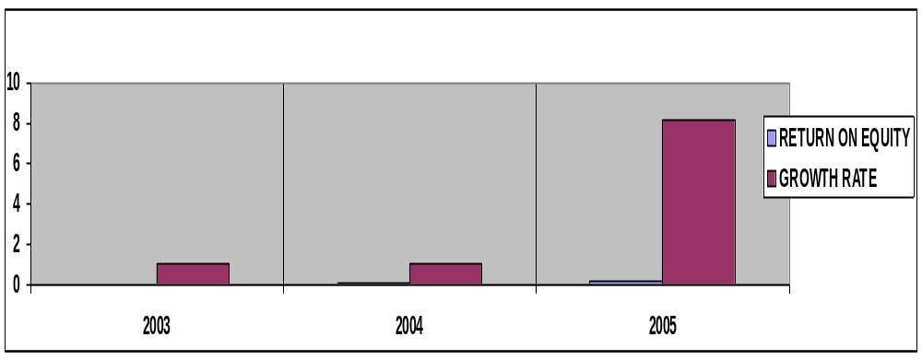

5)CAPITAL STRUCTURE

WACC (WEIGHTED AVERAGE COST OF CAPITAL):

WACC = {Wd * Kdt(1 - Tax Rate)} + {We * Ke)

YEAR | 2005 | 2004 | 2003
Equity | 555,231 | 523,815 | 496,913
Debt | 289,420 | 165,903 | 129849
Total Capital | 844,651 | 689,718 | 626,762
Weight of Equity | 0.66 | 0.76 | 0.79
Weight of Debt | 0.34 | 0.24 | 0.21
Cost Of Equity (CAPM) | 9.57% | 9.57% | 9.57%
Cost of Debt | 34.27 | 24.05 | 20.72
WACC | 7.69 | 3.83 | 2.87

Service Industry’s overall capital structure is not optimal because to consider it optimal its parameters are pre-defined which range between (35% to 45%) and in this case in year 2005 firm’s structure is just about optimal but it not as much as required.

6) LAST YEAR YIELD

DIVIDEND YIELD = DIVIDEND PER SHARE X 100

INITIAL MARKET PRICE

YEAR | DIVIDEND PER SHARE | SHARE MARKET PRICE | DIVIDEND YIELD
2002 |  | 31
2003 | 1 | 25 | 3.225806452
2004 | 1.5 | 29.3 | 6
2005 | 2 | 28.65 | 6.825938567

CAPITAL GAIN YIELD:

CAPITAL GAIN YIELD = CAPITAL GAIN

INITIAL MARKET PRICE

YEAR | SHARE MARKET PRICE | CAPITAL GAIN
2002 | 31
2003 | 25 | -19.35483871
2004 | 29.3 | 17.2
2005 | 28.65 | -2.218430034

7) ACTUAL RATE OF RETURN, REQUIRED RATE OF RETURN, EXPECTED RATE OF RETURN, DIVIDEND DISCOUNT MODEL, INFINITE DIVIDEND PAYMENTS, CAPM

ACTUAL RATE OF RETURN:

ACTUAL RATE OF RETURN = CAPITAL GAIN YEILD + DIVIDEND YEILD

= D1 + (P1-Po)

Po

YEAR | CAPITAL GAIN | LAST YEAR YIELD | ACTUAL RATE OF RETURN
2003 | -19.35483871 | 3.22580645 | -16.12903226
2004 | 17.2 | 6 | 23.2
2005 | -2.218430034 | 6.82593857 | 4.607508536

EXPECTED RATE OF RETURN(INDUSTRY):

EXPECTED RATE OF RETURN(INDUSTRY) = Rf+β(Rm - Rf)

= 8.85+1(8%)

= 16.85

CALCULATION OF COMPANY BETA:

(BETA ) β= COVARIANCE
σ S X σ m

= 285.20
2.21 x 1440.17

β = 0.09

EXPECTED RATE OF RETURN (COMPANY):

EXPECTED RATE OF RETURN (COMPANY) = Rf + β(Rm-Rf)

= 8.85 + .09(8%)

=9.57%

DIVIDEND DISCOUNT MODEL :

DIVIDEND DISCOUNT MODEL = D1 + p1

1 + r

YEAR | DIVIDEND PER SHARE | EXPECTED RATE OF RETURN (%) | SHARE MARKET PRICE | DIVIDEND DISCOUNT MODEL
2003 | 1 | 9.57 | 25 | 23.72912294
2004 | 1.5 | 9.57 | 29.3 | 28.10988409
2005 | 2 | 9.57 | 28.65 | 27.97298531

INFINITE DIVIDEND PAYMENTS:

Po = D1
r

YEAR | DIVIDEND PER SHARE | EXPECTED RATE OF RETURN (%) | INFINITE DIVIDEND PAYMENTS
2003 | 1 | 9.57 | 10.44932079
2004 | 1.5 | 9.57 | 15.67398119
2005 | 2 | 9.57 | 20.89864159

Service Industries Limited

Beta Calculation
Month | KSE 100 index | Share Price
Dec-05 | 9,556.61 | 29.00
Nov-05 | 9,025.93 | 24.00
Oct-05 | 8,247.34 | 25.00
Sep-05 | 8,225.66 | 24.25
Aug-05 | 7,796.86 | 25.50
Jul-05 | 7,178.93 | 21.60
Jun-05 | 7,450.12 | 23.75
May-05 | 6,857.67 | 25.00
Apr-05 | 7,104.65 | 24.10
Mar-05 | 7,770.33 | 27.00
Feb-05 | 8,260.06 | 31.35
Jan-05 | 6,747.39 | 25.75
Dec-04 | 6,218.40 | 29.50
Nov-04 | 5,567.79 | 22.60
Oct-04 | 5,332.24 | 23.75
Sep-04 | 5,217.65 | 25.00
Aug-04 | 5,346.15 | 25.00
Jul-04 | 5,289.92 | 25.65
Jun-04 | 5,279.18 | 26.00
May-04 | 5,497.79 | 26.50
Apr-04 | 5,430.43 | 27.20
Mar-04 | 5,106.67 | 28.40
Feb-04 | 4,840.37 | 25.65
Jan-04 | 4,841.33 | 25.75
SDm | 1,440.17
SDs |  | 2.21
CV | 285.20
β | 0.09

8)BREAK EVEN RUPEES

BREAK EVEN RUPEES = FIXED COST___

1 – VARIABLE COST

SALES

YEAR | FIXED COST (RS IN 000) | VARIABLE COST (RS IN 000) | SALES (RS IN 000) | BREAK EVEN RUPEES
2003 | 228398 | 2308708 | 2632059 | 1859146.907
2004 | 229475 | 2512476 | 2842640 | 1975729.68
2005 | 278061 | 2936875 | 3405185 | 2021842.682

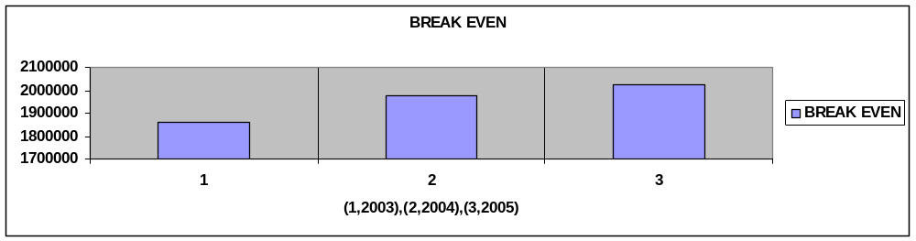

DEGREE OF OPERATING LEVERAGE:

DEGREE OF OPERATING LEVERAGE = 1 + FIXED COST

EBIT

YEAR | FIXED COST (RS IN 000) | EBIT (RS IN 000) | DOL
2003 | 228398 | 100721 | 3.267630385
2004 | 229475 | 107347 | 3.137693648
2005 | 278061 | 198400 | 2.401517137

9)COMPARISON OF REQUIRED RETURN WITH ACTUAL RATE OF RETURN

YEAR | EXPECTED RATE OF RETURN (%) | ACTUAL RATE OF RETURN
2003 | 9.57 | -16.12903226
2004 | 9.57 | 23.2
2005 | 9.57 | 4.607508536

COMPARSION OF ACTUAL PRICE WITH CALCULATED PRICE

YEAR | CACULATED PRICE | ACTUAL PRICE
2003 | 23.73912294 | 25
2004 | 28.11988409 | 29.3
2005 | 27.97298531 | 28.65
Service Industries calculated price is less than actual price which is not a good sign for investors to invest in this company right now. It is clear that share price is over-valued than actually it should be.

10)RATIOS

LIQUIDITY RATIO:

CURRENT RATIO = CURRENT ASSETS

CURRENT LIBILITIES

YEAR | CURRENT ASSETS (RS IN 000) | CURRENT LIBILITIES (RS IN 000) | CURRENT RATIO
2003 | 1571014 | 1345659 | 1.167468133
2004 | 1693463 | 1406993 | 1.203604424
2005 | 1797531 | 1482830 | 1.212229993
The current ratio of the company is decreasing which is not good for the company.

QUICK RATIO = CURRENT ASSETS – INVENTORIES

CURRENT LIBILITIES

YEAR | CURRENT ASSETS (RS IN 000) | CURRENT LIBILITIES (RS IN 000) | INVENTORIES (RS IN 000) | QUICK RATIO
2003 | 1571014 | 1345659 | 742609 | 0.615612871
2004 | 1693463 | 1406993 | 737840 | 0.679195277
2005 | 1797531 | 1482830 | 792160 | 0.678008268

Quick ratio is increasing so it means company is doing well.

NETWORKING CAPITAL = CURRENT ASSETS - CURRENT LIABILITIES

NETWORKING CAPITAL RATIO = NETWORKING CAPITAL

TOTAL ASSET

YEAR | CURRENT ASSETS (RS IN 000) | CURRENT LIBILITIES (RS IN 000) | NETWORKING CAPITAL | TOTAL ASSETS (RS IN 000) | NETWORKING CAPITAL RATIO
2003 | 1571014 | 1345659 | 225355 | 1972421 | 0.114252992
2004 | 1693463 | 1406993 | 286470 | 2096711 | 0.136628272
2005 | 1797531 | 1482830 | 314701 | 2327481 | 0.135210986
Service Industries analysis shows that net working capital ratio is increasing on gradual basis.

LEVERAGE RATIOS:

TOTAL DEBT RATIO = TOTAL LIBILITY

TOTAL ASSETS

YEAR | TOTAL ASSETS (RS IN 000) | TOTAL LIBILITY (RS IN 000) | TOTAL DEBT RATIOS
2003 | 1972421 | 1475508 | 74.80695044
2004 | 2096711 | 1572896 | 75.01730091
2005 | 2327481 | 1772250 | 76.14455284
Debt ratio is increasing which is not a good sign for the company.

TIMES INTREST EARNED RATIO = EBIT______

INTREST PAYMENT

YEAR | EBIT (RS IN 000) | INTREST PAYMENT (RS IN 000) | TIMES INTREST RATIO
2003 | 100721 | 78481 | 1.283380691
2004 | 107347 | 70221 | 1.52870224
2005 | 198400 | 124064 | 1.59917462

Increasing time interest earned ratio is positive sign for the company.

EQUITY TO ASSET RATIO = TOTAL EQUITY

TOTAL ASSETS

YEAR | TOTAL EQUITY (RS IN 000) | TOTAL ASSETS (RS IN 000) | EQUITY TO ASSET RATIO
2003 | 496,913 | 1972421 | 0.251930496
2004 | 523,815 | 2096711 | 0.249826991
2005 | 555,231 | 2327481 | 0.238554472
Equity to assets ratio is decreasing which means in this respect company’s performance is not optimal.

EFFICIENCY RATIOS:

TOTAL ASSETS TURNOVER = SALES

AVERAGE TOTAL ASSET

YEAR | SALES (RS In 000) | TOTAL ASSETS (RS IN 000) | AVERAGE TOTAL ASSET | TOTAL ASSETS TURNOVER
2002 |  | 1855240
2003 | 2632059 | 1972421 | 2841450.5 | 0.926308236
2004 | 2842640 | 2096711 | 3020776.5 | 0.941029566
2005 | 3405185 | 2327481 | 3260451.5 | 1.044390631
Total assets to turn over ratio is highest one in 2005 which means as compare to previous years

DAYS SALES OUTSATNDING = RECEIVABLES

AVERAGE SALES PER DAY

YEAR | RECEIVABLES (RS IN 000) | AVERAGE SALES PER DAY | DAYS SALES OUTSATNDING
2003 | 825482 | 7311275 | 0.112905341
2004 | 950612 | 7896222.222 | 0.120388203
2005 | 1000614 | 9458847.222 | 0.105786041
Service Industries days sales outstanding is good in 2005 as compare to previous years.

INVENTORY TURNOVER = COST OF GOOD SOLD

AVERAGE INVENTORY

YEAR | COST OF GOOD SOLD (RS IN 000) | INVENTORIES (RS IN 000) | AVERAGE INVENTORY (RS IN 000) | INVENTORY TURNOVER
2002 |  | 671890
2003 | 2308708 | 742609 | 707249.5 | 3.264347306
2004 | 2936875 | 737840 | 740224.5 | 3.394208108
2005 | 2512476 | 792160 | 765000 | 3.839052288
Inventory turnover is highest from previous year which shows healthy indicator for the company.

PROFITABILITY RATIOS:

PROFIT MARGIN = NETINCOME X 100

SALES

YEAR | NETINCOME (RS IN 000) | SALES (RS IN 000) | PROFIT MARGIN ON SALES
2003 | 8832 | 2632059 | 0.335554788
2004 | 21783 | 2842640 | 0.766294712
2005 | 52259 | 3405185 | 1.534689011
Profit margin on sale is increasing over the years so it means company earning is growing on ongoing basis which is good one for the company.

RETURN ON ASSET= NETINCOME + INTREST

TOTAL ASSET

YEAR | NETINCOME (RS IN 000) | INTREST PAYMENT (RS IN 000) | TOTAL ASSETS (RS IN 000) | RETURN ON ASSET
2002
2003 | 8832 | 78481 | 1,972,421 | 0.044266919
2004 | 21783 | 70221 | 2,096,711 | 0.043880153
2005 | 52259 | 124064 | 2,327,481 | 0.075757009
Return on assets is decreasing so which is not a good sign for the company.

MARKET VALUE RATIO:

PRICE / EARNING RATIO= PRICE PER SHARE

EARNING PER SHARE

YEAR | SHARE MARKET PRICE | EPS | PRICE EARNING RATIO
2003 | 25 | 0.73 | 34.24657534
2004 | 29.3 | 1.81 | 16.1878453
2005 | 28.65 | 4.34 | 6.601382488
P/E Ratio is increasing but this increase is inconsistent so it is not effective one.

MARKET/BOOK RATIO = MARKET PRICE OF SHARE

BOOK VALUE

YEAR | SHARE MARKET PRICE | EQUITY (RS IN 000) | NUMBER OF SHARE OUTSTANDING (IN 000) | BOOK VALUE | M/B RATIO
2003 | 25 | 496,913 | 12,029 | 41.30958517 | 0.605186421
2004 | 29.3 | 523,815 | 12,029 | 43.5460138 | 0.672851484
2005 | 28.65 | 555,231 | 12,029 | 46.15770222 | 0.620698142

Service Industries book value is under-revalued as compare to its market price so it means its very attractive to invest in it in short basis to get the advantage of less price prevailing in the market.

11) RECOMMANDATION

Service Industries is doing well for so many years and giving healthy dividend to its share holders but there is always room for improvement. Most importantly its share price is overvalued in books as compare to the market actual price which give investors an opportunity to get extra benefits from the company so being an investor I should invest in Service Industries to get short term benefits because in long term there is no proper prediction about price fluctuation in the market. According to its financial analysis it is clear that company is now trying to pay-off its debts which is good strategy to overcome its financial burden. Company ratio’s analysis is quite satisfactory as a whole. Company should review their treatment towards their long term liabilities.

Balance Sheet As at December 31 | 2005 | 2004 | 2003
 | (Rupees In Thousand)
Equity & liabilities
Share Capital & Reserve
share capital | 120288 | 120288 | 120288
Reserves | 384355 | 378201 | 376155
Unappropriate profit | 5588 | 25326 | 470
 | 555231 | 523815 | 496913
Non Current liabilities
Long term Loans | 190000 | 110000 | 50000
Liabilities against assets subject to finance lease | 75361 | 30130 | 50384
Deferred Liabilities | 23709 | 25723 | 29415
long Term Deposits | 350 | 50 | 50
 | 289420 | 165903 | 129849
Current Liabilities
Short Term Borrowings | 839736 | 790713 | 787961
Current Portion:
Long Term Loans | 32500 | 72500 | 50000
Liabilities against assets subject to finance lease | 22080 | 27225 | 20199
Trade & Other Payables | 571437 | 502337 | 473817
provision For Taxation | 17077 | 14218
dividend Payable |  |  | 13682
 | 1482830 | 1406993 | 1345659
Contingencies & Commitments
TOTAL | 2327481 | 2096711 | 1972421
Fixed Assets
Property, Plants & Equipment | 396281 | 309696 | 307068
Fixed assets subject to finance lease | 102027 | 70077 | 73519
Capital Work In Progress | 7106 | 1162 | 891
 | 505414 | 380935 | 381478
Long Term Investment | 7200 | 10053 | 4934
Long Term Deposits | 17336 | 12260 | 14995
Current Assets
Stores, Spares & loose tools | 13395 | 10741 | 10376
Stock In Trade | 778765 | 727099 | 732233
Trade Debts | 785172 | 734982 | 607837
Advances, Deposits, Prepayments & receivables | 215442 | 215630 | 217645
Cash & Bank Balance | 4757 | 5011 | 2923
 | 1797531 | 1693463 | 1571014
TOTAL | 2327481 | 2096711 | 1972421

Profit and Loss Account | 2005 | 2004 | 2003 | 2002
For the Year Ended December 31
 | (Rupees In 000)
Sales | 3405185 | 2842640 | 2632059 | 256720
Cost of sales | 2936875 | 2512476 | 2308708
Gross Profit | 468310 | 330164 | 323351 | 40005
Operating Expenses
Selling & distribution expenses | 115012 | 89689 | 92126
Administrative expenses | 163049 | 139786 | 136273
 | 278061 | 229475 | 228398
Operating Profit | 190249 | 100689 | 94953
Other income | 8151 | 6658 | 5768
 | 198400 | 107347 | 100721
Financial expenses | 116075 | 64485 | 74136
other expenses | 7989 | 5736 | 4345
 | 124064 | 70221 | 78481
Profit Before Taxation | 74336 | 37126 | 22240 | 6023
Taxation | 22077 | 15343 | 13408
Profit After taxation | 52259 | 21783 | 8832 | 4723
Profit & Loss Appropriation Account
unappropriated profit brought forward |  |  | 467
Transferred to general reserve |  |  | 3200
 |  |  | 12499
Appropriations
Cash dividend @ 15% (2003; @ 10%) |  |  | 12029
Transferred to general reserve |  |  | -
 |  |  | 12029
Unappropriated Profit Carried Forward |  |  | 470
Earning per share - (Rupees) | 4.34 | 1.81 | 0.73

BIBLOGARPHY

http://www.brecorder.com/index.php?currExchange=K&currPageType=D&currSector=33&stocks=stocks%2Fmframe.php&currDate=2005-10-31&scrType=1024%7C768

Richard A. Brealey , Stewart C. Myers & Alan j. Marcus .Corprate Finance 4th Edition.

